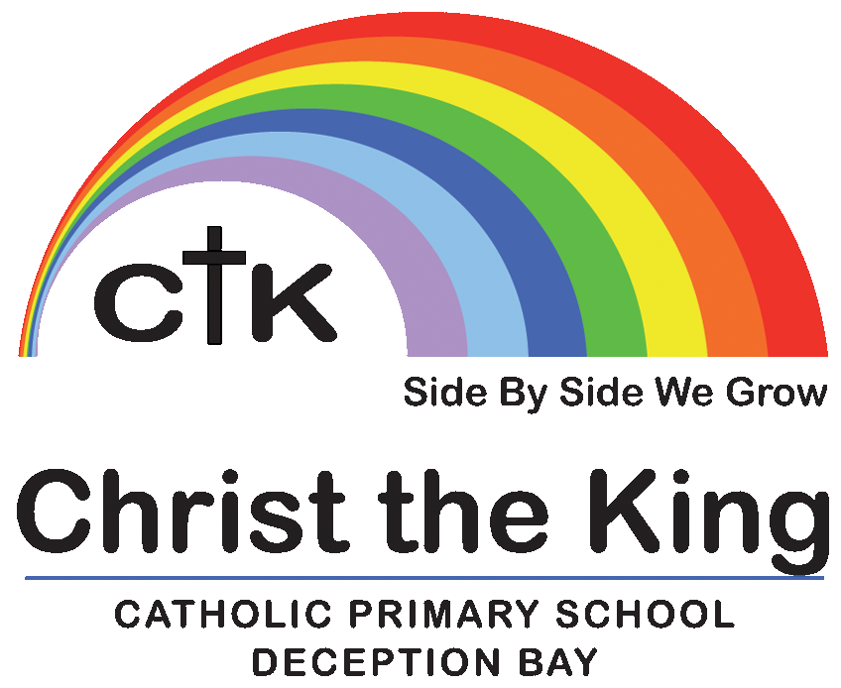
School Uniform.

Student’s individuality is appreciated at Christ the King. However, we do have a compulsory school uniform. It is our expectation that all children leave home looking not only a credit to their families, but also to the school to which they belong. Therefore the following responsibilities apply to parents and students;

- The children are to wear the school uniform travelling to and from school, as well as during school hours. This includes the school hat.
- By way of courtesy, parents are asked to write a letter to the classroom teacher if their child is ‘out of uniform, e.g. wearing incorrect shoes.’
- All items of clothing must be labelled clearly with the child’s name.

Hair:
- Hair is to be kept clean, neat and tidy and out of the eyes.
- If longer than collar length, it should be tied back. (boys and girls)
Hair should be tied back with a dark navy blue, brown or black hair tie or simple hair accessories in school uniform colours.
- Hair must remain its natural colour.
- Undercut patterns in hair or carvings in hair are not permitted. This includes
- extreme variations in length (some shaved and some long).

Make up
- No make-up or coloured lip gloss is permitted.

Fingernails:
- Fingernails must be clean, well trimmed and unpolished.

Jewellery:
Wearing jewellery to school poses a health and safety risk, as such the range jewellery that children may choose to wear is limited to;
- A single set of plain earrings (studs or sleepers)
- A watch
- A small, plain, religious, or cultural item or cross worn around the neck.

Hats:
- We request that children have sunscreen applied at home. It can be reapplied during the day and is supplied in each classroom.
- As sun safety is of great concern, all children must have a school hat for outdoor activities, as well as travelling to and from school.
- The rule “No hat, No play” applies to all class activities and lunchtime play.
- Only school hats are permitted.

Shoes:
- Formal uniform: Shoes must be plain black, leather or synthetic leather school shoes.
- Velcro strap shoes are permitted.
- Sports uniform: Sport shoes appropriate for playing sport.

Socks:
- Socks are to be plain white socks with CTK lettering which completely cover the ankle bone.

School bag
- Official CTK school bag

Sports Uniform:

- Consists of a polo shirt with sports house-coloured trim. Sports house will be allocated on enrolment;
- Bribie House – Red
- Stradbroke House – Blue
- Moreton House – Green
- Prep students only wear Sports uniform.
- Year 1-6: The Sports uniform is to be worn on designated sports days which will be determined by the class teacher. Prep students only wear Sports uniform
- There is a formal uniform which can be worn at other times.

School Uniform:
This uniform is available from our uniform shop.

 | Formal | Sport
Summer | School Formal Dress  or  School Formal Blouse or Shirt  with  Dark navy gabardine culottes or Dark navy garbardine school shorts  CTK socks  Plain black, leather or synthetic leather school shoes | Official school polo shirt with house colour trim,  with  Dark navy blue unisex CTK shorts  or  Dark navy blue skort with rainbow emblem  CTK socks  Sports shoes.  .
Winter | - The winter uniform is as above, however:  - Students are permitted to wear singlets which are either not visible, or which are dark navy blue or white.  - Dark navy blue or white skivvies can be work underneath both school uniforms.  - Dark navy blue CTK tracksuit pants are permitted.  - Official school microfiber jacket or knitted CTK Jumper.  - Full length footed tights / stockings are permitted in plain dark navy blue.

The school may slightly alter or delete items from the uniform at anytime, however an appropriate amount of time will be given, to allow for an adjustment period. If you are unsure about an item of clothing please check with the school.

Some guiding procedures:
A standard letter is used to inform parents of any concerns regarding their child’s school uniform.
Parents are then given a period of time to act on the letter.
Students who continue to attend school with the incorrect uniform, without a note from their parents may be excluded from playtime.
Any ongoing problems are to be referred to the principal, who in turn will discuss concerns with parents.

Parents have the responsibility for overseeing the wearing of correct school uniform.

DRESS CODE FOR UNIFORM FREE DAY- “FREE DRESS” DAYS:
When uniform free days operate children are to wear clothing which complies with all of the following. We are a Sun Smart School and students clothing must be sunsafe:
- Closed in shoes, which are suitable for running
- Clothing which covers the full torso and shoulders
- Dresses/shorts to be to at least mid-thigh length
- School hats are to be worn (wide brimmed hat not caps).
- No offensive or inappropriate slogans/pictures

Children not complying may be asked to:
- Return home and change clothing to suit the policy or
- Wear clothing provided at the school which does comply or
- Be refused the privilege in future

